Welcome to Cookworthy Forest
In the heart of Ruby Country

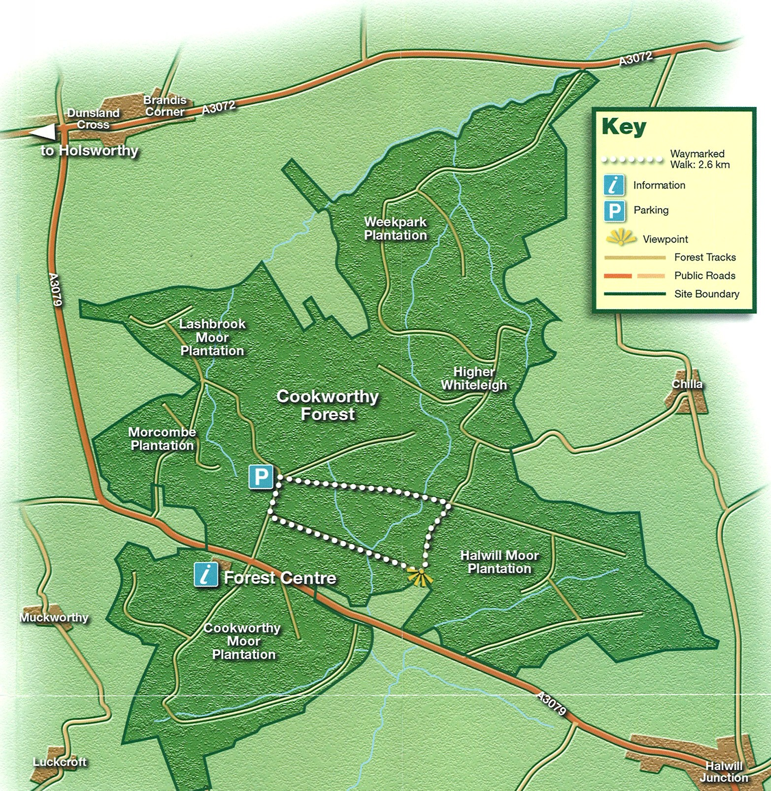
Forest Trail
Nature Area

Cookworthy Forest Trail

This circular route starts and finishes at the main car park, opposite the centre, and takes you into the heart of this magnificent conifer plantation. The trail is two miles long and will take approximately one hour. The trail is not marked on the ground, but follows clearly defined forest rides.

Nature Area

Behind the Forest Centre is a nature area, developed through the South West Forest Project. This has ponds and wildflower meadows as well as a range of small tree and shrub plantings designed specifically to attract a range of wildlife. You are welcome to walk the informal network of paths in this area, which also has a replica roundhouse used for education visits (pictures overleaf).

Cookworthy Forest Centre

The centre was previously the base for South West Forest, a major project which led to the planting of 10,000 acres of additional woodland in North Devon and North Cornwall. The project closed in 2009, and the centre is now run by the Ruby Country Partnership. Units within the centre are let to commercial businesses. Please respect the privacy of these businesses.

Ruby Country (www.therubycountry.com)


Ruby Country covers 45 parishes around Holsworthy and Hatherleigh. The Ruby Country Partnership is a not for profit business and works with local businesses and communities to help build a stronger and more robust financial and social future. The area is outstanding as a food & drink producer and is a great centre for leisure & tourism, as well as offering a wide range of services. The Ruby Business Network exists to help businesses of all sizes succeed through positive promotion of the area and by collective working to achieve common aims and a self-supporting future. The Ruby Country Partnership also works closely with a variety of partners to promote the conservation of the unique environment and landscape of Ruby Country, including internationally rare culm grassland.
Ride the Ruby Country is an equestrian and sustainable tourism project, working with businesses and communities to make the most of the opportunities arising from the development of multi-use trails in Ruby Country with the aim of making the area a destination of choice for visitors and creating more recreation opportunities for local residents. For more information on the project, visit www.ridetherubycountry.co.uk.

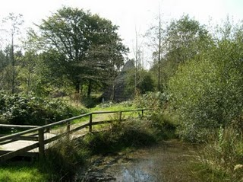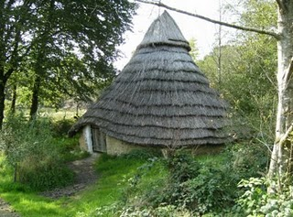

Forestry Commission

Cookworthy remains the operational base for a small team of staff managing our West Devon woodlands. However, our staff are usually out in the woods, and our office is infrequently staffed. For general enquiries, please contact the Peninsula Office, Bullers Hill, Kennford, Exeter, EX6 7XR. Telephone 01392 832 262.

Other woods you may wish to visit in the area include:

Holsworthy Wood

Abbeyford Wood, near Okehampton

Lydford Wood, between Launceston and Okehampton.

Or for a full day out, with café and other facilities, we recommend either Haldon Forest Park, near Exeter or Cardinham Woods near Bodmin.

